Question 1
Recreate the following web layout:
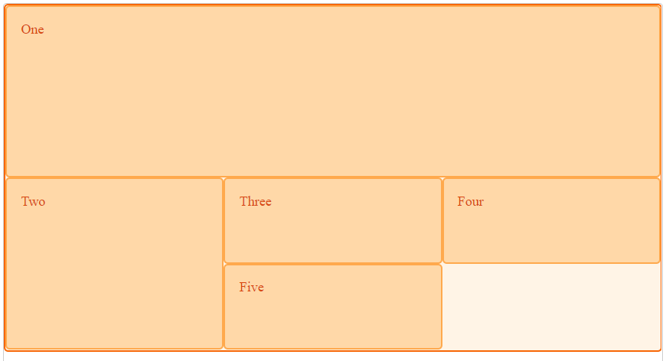
Utilize CSS grid layout.

Question 2
Recreate the following web layout:
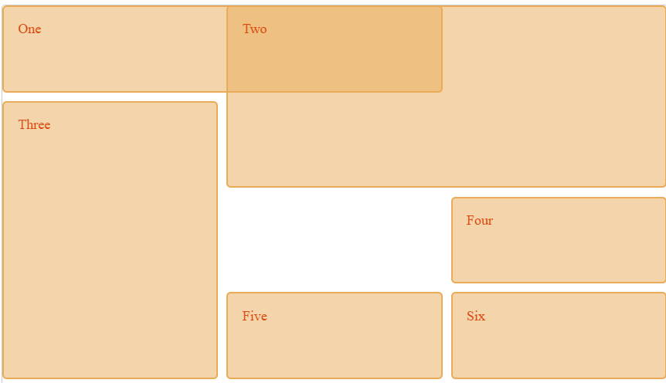
Utilize CSS grid layout.

https://developer.mozilla.org/en-US/docs/Web/CSS/CSS_Grid_Layout

Question 3
Recreate the following web layout:

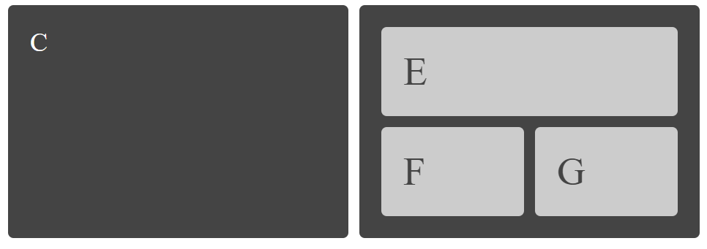
Utilize CSS grid layout and nested grids

Question 4
Recreate the following web layout:
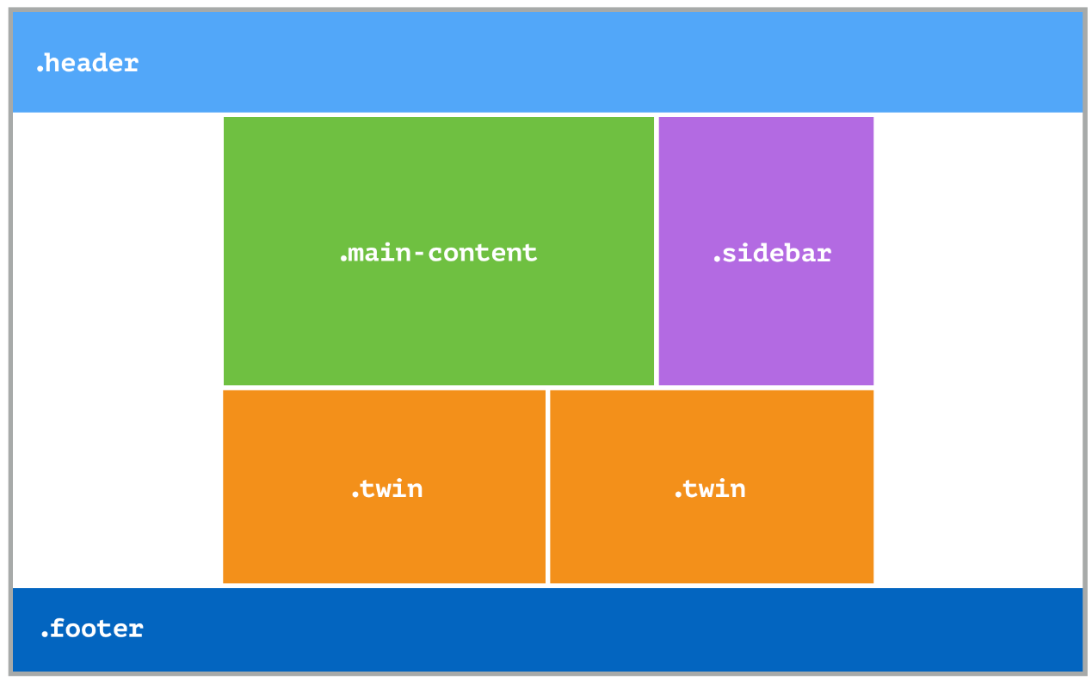

Utilize grid-areas

Question 5
Recreate the following web layout:
